Project Design Phase-II
Data Flow Diagram & User Stories

Date | 31 January 2025
Team ID
Project Name | RentEase - House Rent Management System
Maximum Marks | 4 Marks

Data Flow Diagrams:
A Data Flow Diagram (DFD) is a traditional visual representation of the information flows within a system. A neat and clear DFD can depict the right amount of the system requirement graphically. It shows how data enters and leaves the system, what changes the information, and where data is stored.
Example: DFD Level 0 (Industry Standard)
Example: (Simplified)
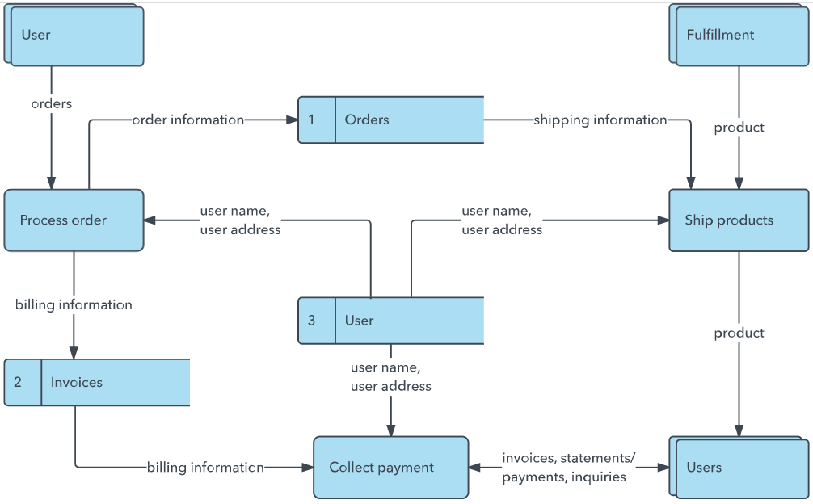


User Stories
Use the below template to list all the user stories for the product.
User Type | Functional Requirement (Epic) | User Story Number | User Story / Task | Acceptance criteria | Priority | Release
Tenant (Customer) | Registration | USN-1 | As a tenant, I can register by entering my name, email, password, and phone number. | Account is created and I can log in immediately after. | High | Sprint-1
 |  | USN-2 | As a tenant, I can log in with my email and password to receive a secure session. | I receive a valid JWT token and access my dashboard. | High | Sprint-1
 | Property Search | USN-3 | As a tenant, I can browse all active property listings. | Listings load with photo, price, and location visible. | High | Sprint-1
 |  | USN-4 | As a tenant, I can filter listings by location, bedrooms, and max budget. | Only matching listings are shown after filtering. | Medium | Sprint-2
 | Booking | USN-5 | As a tenant, I can view full property details and submit a booking request with one click. | Request is saved and flagged if it conflicts with an existing booking. | High | Sprint-2
 | Dashboard | USN-6 | As a tenant, I can view my submitted applications with status, ID, and host phone number. | Dashboard lists all my requests with current approval status. | Medium | Sprint-2
Customer (Web user) | Property Search | USN-7 | As a web visitor, I can browse listings without creating an account. | Public listing pages are viewable pre-login. | Low | Sprint-3
Customer Care Executive | Support | USN-8 | As support staff, I can look up a tenant's booking status to answer queries. | Booking record is retrievable by tenant/application ID. | Low | Sprint-4
Administrator | Property Management | USN-9 | As an admin, I can add, edit, or delete property listings with multiple images. | Property changes reflect immediately in the public listing. | High | Sprint-3
 | Booking Management | USN-10 | As an admin, I can approve or reject tenant booking requests. | Approving a request marks the property unavailable automatically. | High | Sprint-3
 | User Management | USN-11 | As an admin, I can view a directory of all registered tenants and admins. | User list loads with role, name, and contact details. | Medium | Sprint-4

Our Data Flow Diagram (RentEase)
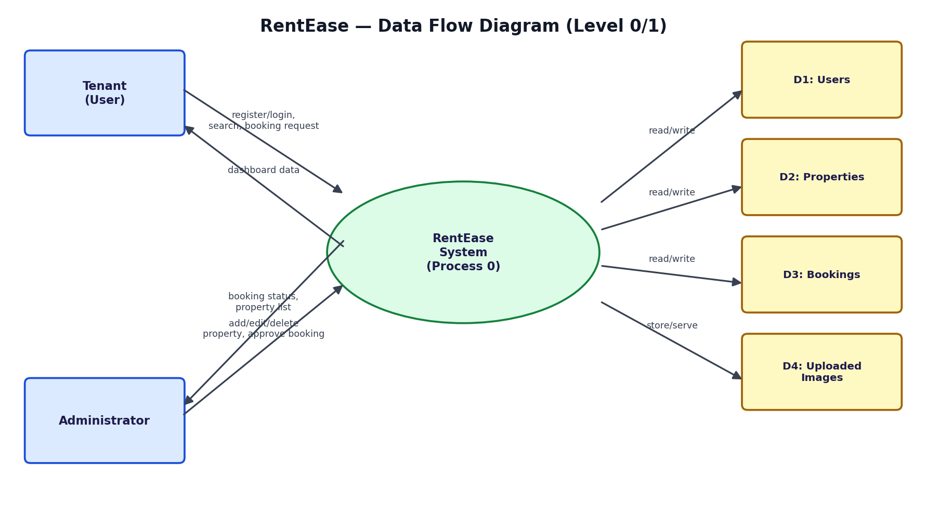
Figure: Level 0/1 Data Flow Diagram showing Tenant and Administrator interactions with the RentEase system and its data stores.

